Churn Reduction

Aaron Rebello

23 January 2019

Contents

1 | Introduction |  |  |  |  | 3
 | 1.1 | Problem Statement . . . . . . . . . . . . . . . . . . . . . . . . . . . . . . . . . . . . . . . . . . |  |  |  | 3
 | 1.2 | Data | . . . . . . . . . . . . . . . . . . . . . . . . . . . . . . . . . . . . . . . . . . . . . . . . . |  |  | 3
2 | Methodology |  |  |  |  | 5
 | 2.1 | Pre Processing . . . . . . . . . . . . . . . . . . . . . . . . . . . . . . . . . . . . . . . . . . . . |  |  |  | 5
 |  | 2.1.1 | Univariate and Bivariate analysis . . . . . . . . . . . . . . . . . . . . . . . . . . . . . . . . . |  |  | 5
 |  | 2.1.2 | Missing Value Analysis and Outlier Analysis . . . . . . . . . . . . . . . . . . . . . . . . . |  |  | 9
 |  | 2.1.3 | Feature Selection . . . . . . . . . . . . . . . . . . . . . . . . . . . . . . . . . . . . . . . |  |  | 13
 |  | 2.1.4 | Feature Scaling . . . . . . . . . . . . . . . . . . . . . . . . . . . . . . . . . . . . . . . . |  |  | 14
 |  | 2.1.5 | Sampling . . . . . . . . . . . . . . . . . . . . . . . . . . . . . . . . . . . . . . . . . . . . . . . . . . . . . |  |  | 14
 | 2.2 | Modelling . . . . . . . . . . . . . . . . . . . . . . . . . . . . . . . . . . . . . . . . . . . . . . . |  |  |  | 16
 |  | 2.2.1 | Decision Tree. . . . . . . . . . . . . . . . . . . . . . . . . . . . . . . . . . . . . . . . |  |  | 16
 |  | 2.2.2 | Random Forest . . . . . . . . . . . . . . . . . . . . . . . . . . . . . . . . . |  |  | 16
 |  | 2.2.3 | Logistic Regression . . . . . . . . . . . . . . . . . . . . . . . . . . . . . . . . . . . . . . . |  |  | 16
 |  | 2.2.4 | KNN model . . . . . . . . . . . . . . . . . . . . . . . . . . .. . . . . . . . . . . . . |  |  | 16
 |  | 2.2. 5 | Naïve bayes. . . . . . . . . . . . . . . . . . . . . . . . . . . . . . . . . . . . . . . . . . . . . . . |  |  | 17
3 | Conclusion
 | 3.1 | Model Evaluation . . . . . . . . . . . . . . . . . . . . . . . . . . . . . . . . . . . . . . . . . . . |  |  |  | 18
 | 3.2 | Model Selection . . . . . . . . . . . . . . . . . . . . . . . . . . . . . . . . . . . . . . . . . . . . |  |  |  | 18
 | 3.3 | Final prediction on test data. . . . . . . . . . . . . . . . . . . . . . . . . . . . . . |  |  |  | 19
Appendix A - R Code |  |  |  |  |  | 21

Chapter 1

Introduction

1.1 Problem Statement

Customer churn means when a customer breaks his relationship with a company. Churn (loss of customers to competition) is a problem for companies because it is more expensive to acquire a new customer than to keep your existing one from leaving. The full cost of customer churn includes both lost revenue and the marketing costs involved with replacing those customers with new ones. So,Reducing customer churn is a key business goal of every business. This problem statement is targeted at enabling churn reduction using analytics concepts.

1.2 Data

The objective of this Case is to predict customer behaviour. We have a public dataset that has customer usage pattern and if the customer has moved or not. We have to develop an algorithm to predict the churn score based on usage pattern. The predictors provided are as follows:
● account length
● international plan
● voicemail plan
● number of voicemail messages
● total day minutes used
● day calls made
● total day charge
● total evening minutes
● total evening calls
● total evening charge
● total night minutes
● total night calls
● total night charge
● total international minutes used
● total international calls made
● total international charge
● number of customer service calls made

Target Variable :
move: if the customer has moved (1=yes; 0 = no)

The structure of the data is :-
data.frame': 3333 obs. of 20 variables:

$ state : Factor w/ 51 levels "AK","AL","AR",..: 17 36 32 36 37 2 20 25 19 50 ...
$ account_length : int 128 107 137 84 75 118 121 147 117 141 ...
$ area_code : Factor w/ 3 levels "408","415","510": 2 2 2 1 2 3 3 2 1 2 ...
$ international_plan : Factor w/ 2 levels " no"," yes": 1 1 1 2 2 2 1 2 1 2 ...
$ voice_mail_plan : Factor w/ 2 levels " no"," yes": 2 2 1 1 1 1 2 1 1 2 ...
$ number_vmail_messages : int 25 26 0 0 0 0 24 0 0 37 ...
$ total_day_minutes : num 265 162 243 299 167 ...
$ total_day_calls : int 110 123 114 71 113 98 88 79 97 84 ...
$ total_day_charge : num 45.1 27.5 41.4 50.9 28.3 ...
$ total_eve_minutes : num 197.4 195.5 121.2 61.9 148.3 ...
$ total_eve_calls : int 99 103 110 88 122 101 108 94 80 111 ...
$ total_eve_charge : num 16.78 16.62 10.3 5.26 12.61 ...
$ total_night_minutes : num 245 254 163 197 187 ...
$ total_night_calls : int 91 103 104 89 121 118 118 96 90 97 ...
$ total_night_charge : num 11.01 11.45 7.32 8.86 8.41 ...
$ total_intl_minutes : num 10 13.7 12.2 6.6 10.1 6.3 7.5 7.1 8.7 11.2 ...
$ total_intl_calls : int 3 3 5 7 3 6 7 6 4 5 ...
$ total_intl_charge : num 2.7 3.7 3.29 1.78 2.73 1.7 2.03 1.92 2.35 3.02 ...
$ number_customer_service_calls: int 1 1 0 2 3 0 3 0 1 0 ...
$ Churn : Factor w/ 2 levels " False."," True.": 1 1 1 1 1 1 1 1 1 1 ...

Chapter 2

Methodology

2.1 Pre Processing

Any predictive modelling requires that we look at the data before we start modelling. However, in data mining terms looking at data refers to so much more than just looking. Looking at data refers to exploring the data, cleaning the data as well as visualizing the data through graphs and plots. This is often called as Exploratory Data Analysis, followed by pre processing.

2.1.1 Univariate and Bivariate analysis:

- Let us see the target variable which has two categories :-
True- customer will churn or move
False – customer will not churn

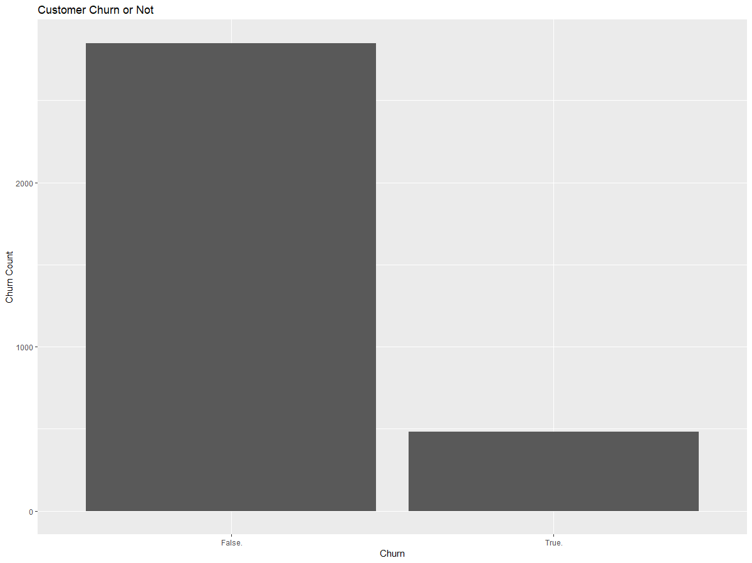

we see that there is a high class imbalance problem as the occurrence of false is way more than true. 85 % customers are not churning out while, 14 % customers are churning out.

2 ) Let us see occurrence of churning according to area code

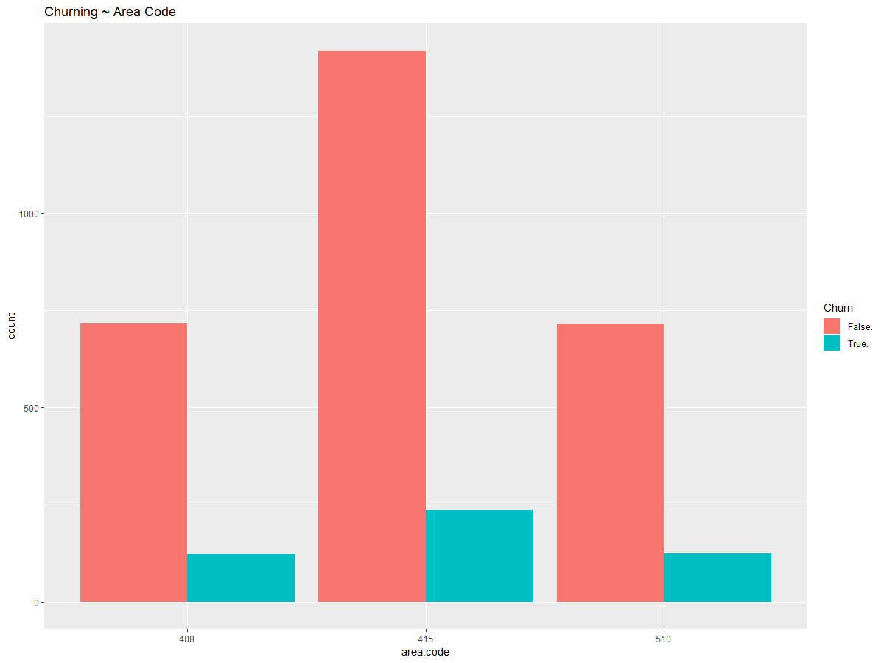

From the above fig, we can infer that the area code 415 has more customers.

- let us see influence of international plan on customer churning
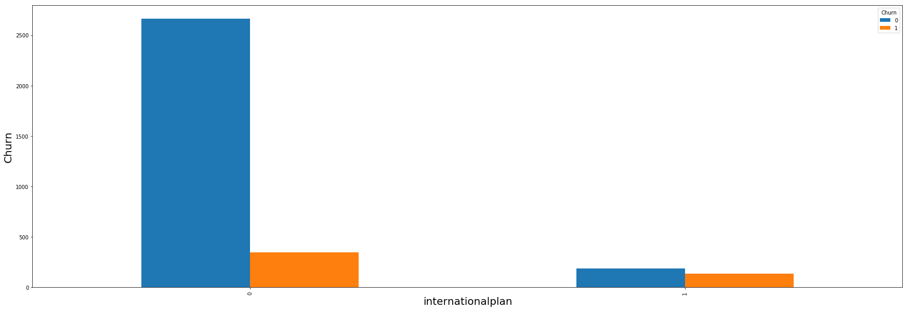

From the above figure, we see that, most of the customers don’t have international plan. And those who has international plan, has more customers churning

- let us see the churning according to international plan and voice mail
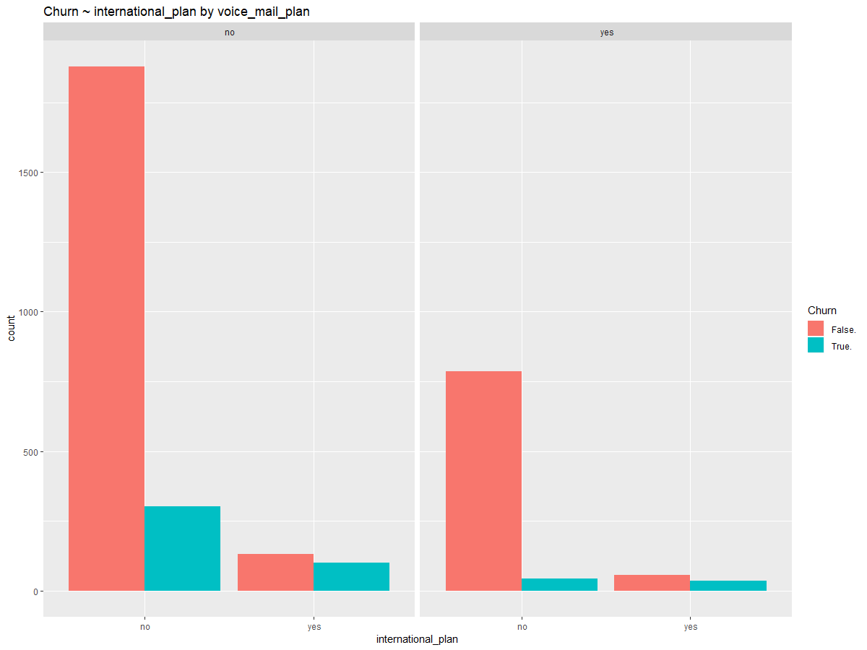

From the above figure, we see that, the customers which has international plan but doesn’t have voice mail plan has more customers churning. Also, the customers with neither of the plan has more customers with them, i.e. not churning .

- let us see the relation between number of customer service calls and churning
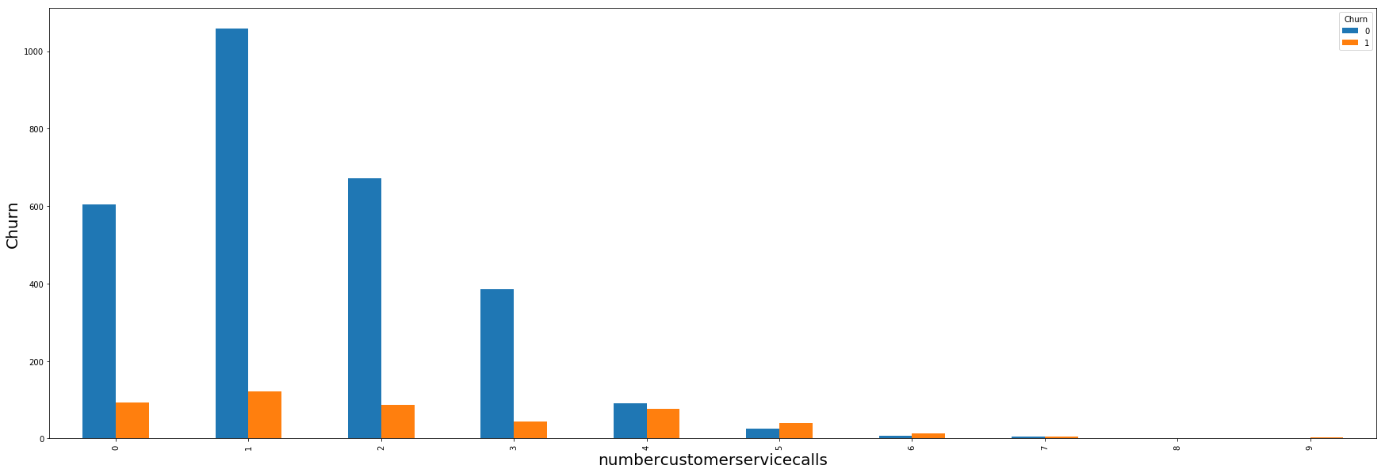

So, from the above figure we see that the as the number of service calls are increasing, the churning of customers are increasing, so the customers serive calss should be reduced in order to maintain the cistomers.

- let us see the graph between different continuos variables
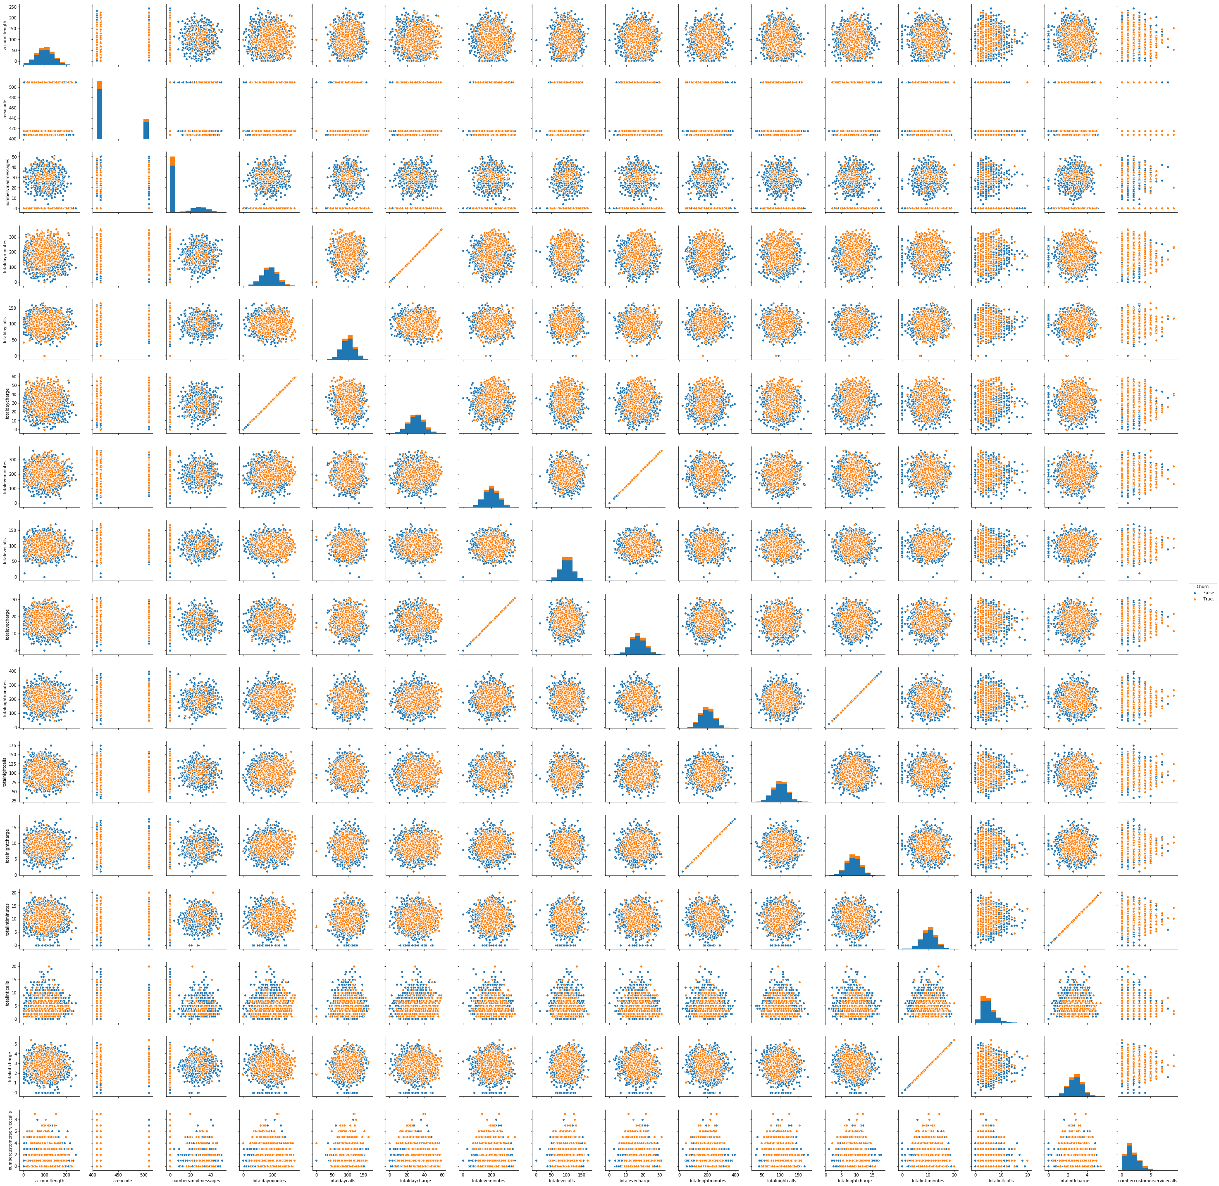

We see that some of the variables are highly correlated which are:-
• total day charge & total day minute
• total eve charge & total eve minute
• total night charge & total night minute
• total intl charge & total intl minute

(more clear image is in the appendix)

2.1.2 Missing value Analysis and Outlier Analysis

Missing values occur when no data value is stored for the variable in an observation. A missing value can signify a number of different things in your data. Perhaps the data was not available or not applicable or the event did not happen. It could be that the person who entered the data did not know the right value, or missed filling in. Missing values are a common occurrence, and you need to have a strategy for treating them. Typically, ignore the missing values, or exclude any records containing missing values, or replace missing values with the mean, or infer missing values from existing values. We check for missing values in our data. We saw that the target variable has most number of missing value which seems to be less than 30% of the total data. And since it the target data we need to impute data. Here, we use KNN imputation and impute the data
Now, we plotted box plot to see if there are any outliers in the data. An outlier is an observation that lies an abnormal distance from other values in a random sample from a population. There are numerous impacts of outliers in the data set. It increases the error variance and reduces the power of statistical tests. If the outliers are non-randomly distributed, they can decrease normality. They can also impact the basic assumption of Regression, ANOVA and other statistical model assumptions.

let us see the missing values:-
accountlength 0
areacode 0
internationalplan 0
voicemailplan 0
numbervmailmessages 0
totaldayminutes 0
totaldaycalls 0
totaleveminutes 0
totalevecalls 0
totalnightminutes 0
totalnightcalls 0
totalintlminutes 0
totalintlcalls 0
numbercustomerservicecalls 0
Churn 0
dtype: int64

So, we see that there are no missing values in the data.

Let us check outliers:-
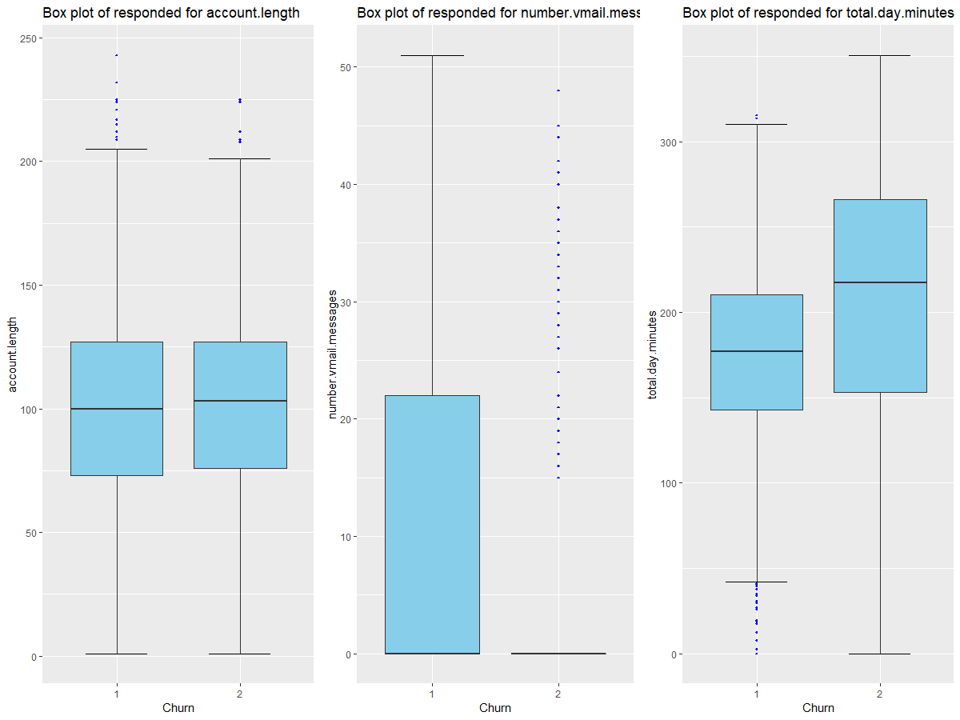

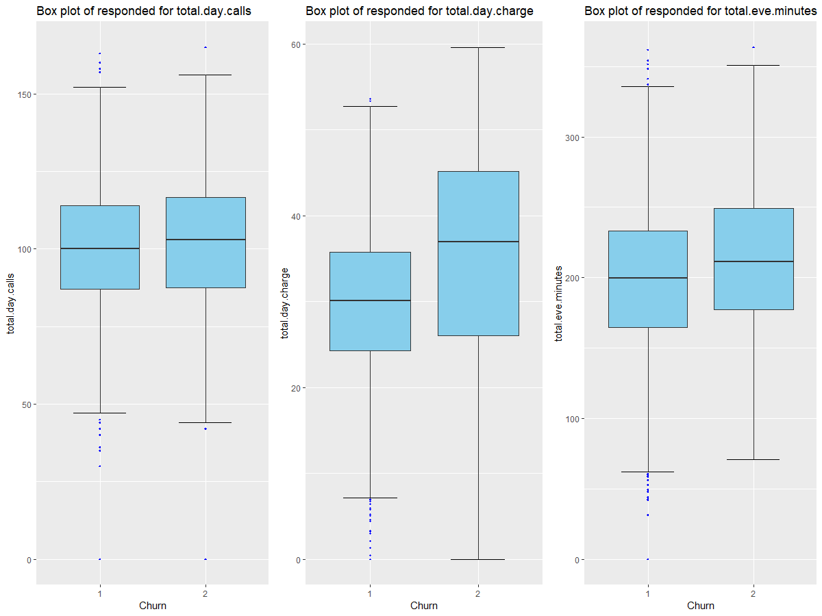

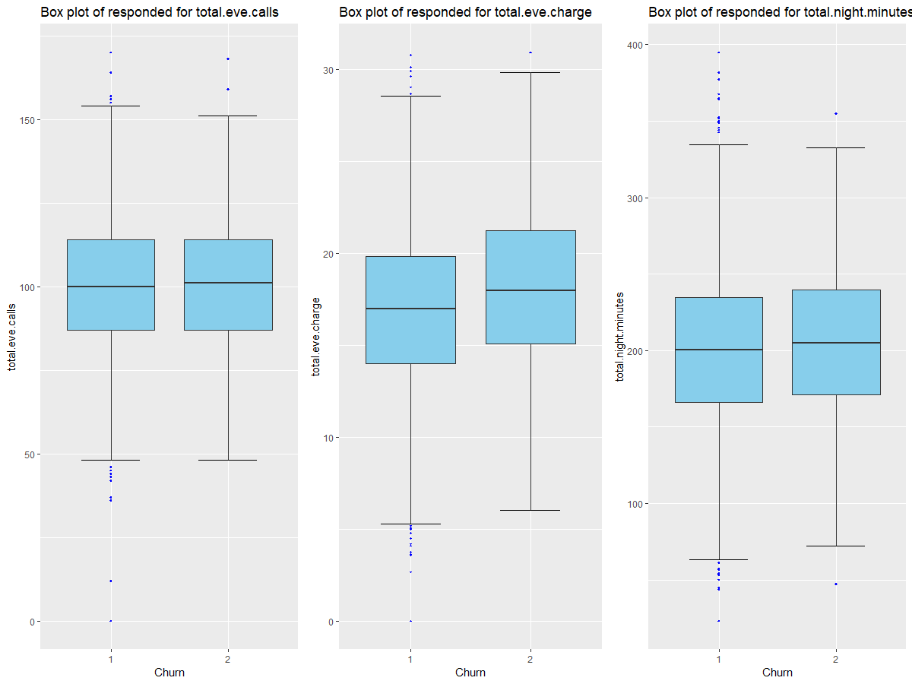

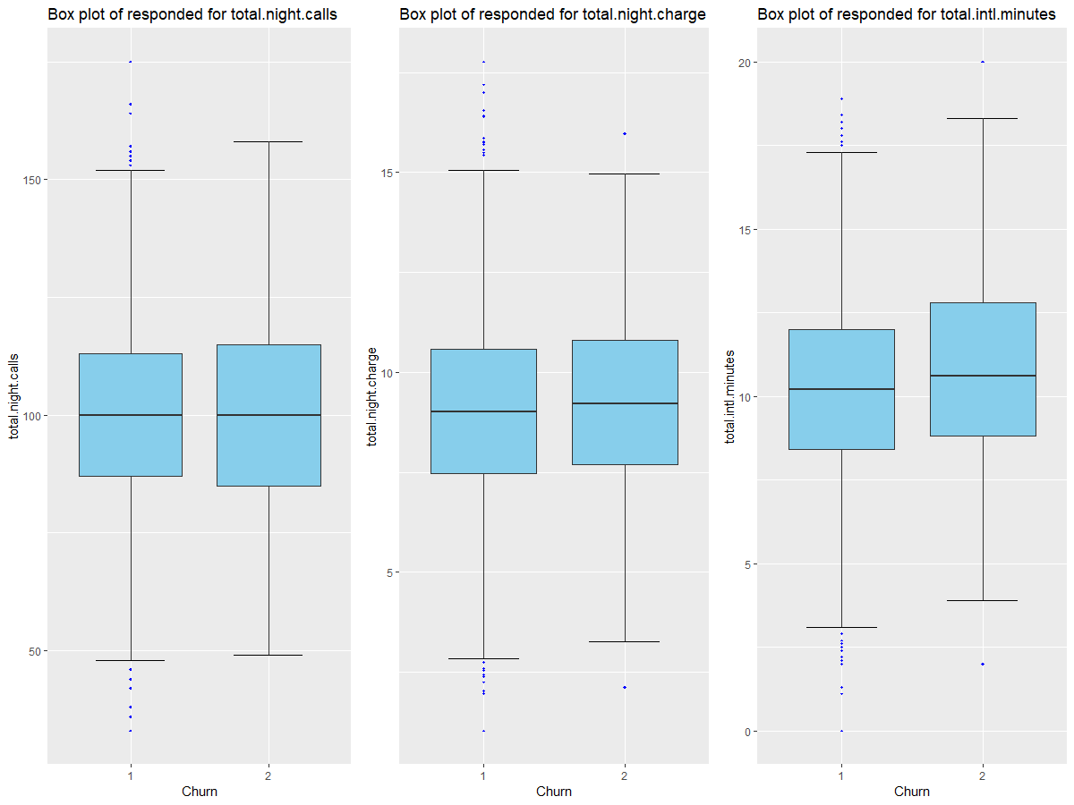

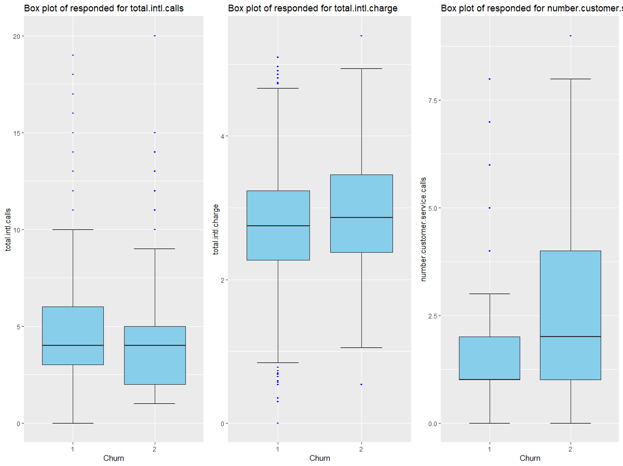

From the above box plots we see that in every variables there are outliers, so let us remove this outliers and impute using knn method.

2.1.3 Feature Selection

Before performing any type of modeling we need to assess the importance of each predictor variable in our analysis. There is a possibility that many variables in our analysis are not important at all to the problem of class prediction. There are several methods of doing that. We are using correlation matrix to identify most correlated numeric variables and anova test for categorical variables.

2.1.3.1 Correlation Matrix
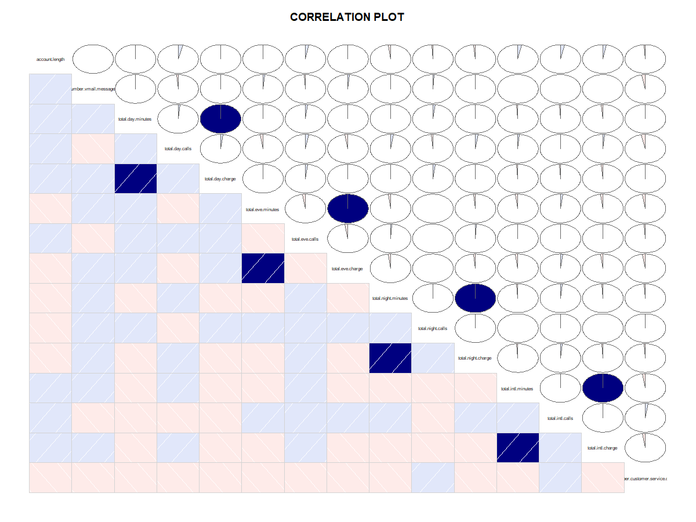
From the above figure we can see the dark blue variables which are highly correlated:-
From the correlation plot we can see that –
• ‘Total day minutes’ and ‘total day charges’ are highly correlated
• ‘Total eve minutes’ and ‘total eve charges’ are highly correlated
• ‘Total night minutes’ and ‘total night charges’ are highly correlated
• ‘Total intl minutes’ and ‘total intl charges’ are highly correlated

2.1.3.2 Chi-square Test

[1] "state"
$`p.value`
[1] 0.002296222

[1] "area.code"
$`p.value`
[1] 0.9150557

[1] "international.plan"
$`p.value`
[1] 2.493108e-50

[1] "voice.mail.plan"
$`p.value`
[1] 5.15064e-09

[1] "Churn"
$`p.value`
[1] 0

After performing chi square test on the categorical variables, we see that the variable, state, has p- value less than 0.05, so we remove this variable because if the p-value is less than 0.05, means that the variable is not dependent and not contributing much information about the target variable.

2.1.4 Feature Scaling

Feature scaling is a method used to standardize the range of independent variables or features of data. In data processing, it is also known as data normalization and is generally performed during the data preprocessing steps. If training an algorithm using different features and some of them are off the scale in their magnitude, then the results might be dominated by them. Therefore, the range of all features should be normalized so that each feature contributes approximately proportionately to the final distance.
As we saw from the data analysis we performed, we see that most of the data is uniformly distributed so we go for standardization.

Standardization :- It will convert mean or Average of each variable to Zero and the each value of variable will convert to unique standard Deviation.

2.1.5 Sampling

In sampling we split the train data into train and test to develop model and check its metrics.
In both, python and R, we use stratified sampling technique to spit data into train and test set.
# after splitting
# 0 1895
# 1 338
After splitting we see that we get the train and test data which is not balanced i.e. target class imbalance problem. So, we need to deal with this imbalance because it can affect the accuracy of the model.

To overcome the imbalanced data problem we will go for over sampling of training data. There are multiple approaches to do over sampling but here we will use synthetic over sampling. In Python we have used SMOTE, while in R we are using ROSE.

→ SMOTE Oversampling in Python:- SMOTE synthesize new minority instances between existing real minority instances. Imagine that SMOTE Draw lines between existing minority instances. Smote then imagine new synthetic minority instance somewhere on that lines. Like it will generate the synthetics of two real minority cases or data points. Applying synthetic minority oversampling technique to overcome the challenge of imbalance dataset as having an imbalance dataset will have negative impact over machine learning model predictions.
In python we use SMOTE

→ ROSE Oversampling in R:- IN R we have used ROSE sampling technique. Which is similar to SMOTE, It also generating the synthetic data points and also it will under sample some random points from majority class.
R before sample
# 1 2
# 1881 319

R after sampling
# 1 = 1101
# 2 = 1099

So, after this our data is ready to be feed to the machine learning model

2.2 Modeling

As we know that our model is a classification model,we have divided the train data into train and test samples, which are to be fitted into the models as bellows:-

    - Decision tree
Decision tree builds regression or classification models in the form of a tree structure. It breaks down a dataset into smaller and smaller subsets while at the same time an associated decision tree is incrementally developed. The final result is a tree with decision nodes and leaf nodes. A decision node (e.g., Outlook) has two or more branches (e.g., Sunny, Overcast and Rainy), each representing values for the attribute tested. Leaf node (e.g., Hours Played) represents a decision on the numerical target. The topmost decision node in a tree which corresponds to the best predictor called root node. Decision trees can handle both categorical and numerical data.

    - Random Forest

The Random Forest is one of the most effective machine learning models for predictive analytics, making it an industrial workhorse for machine learning.

    - Logistic Regression
Logistic regression is a statistical method for analyzing a dataset in which there are one or more independent variables that determine an outcome. The outcome is measured with a dichotomous variable (in which there are only two possible outcomes). In logistic regression, the dependent variable is binary or dichotomous. The goal of logistic regression is to find the best fitting (yet biologically reasonable) model to describe the relationship between the dichotomous characteristic of interest (dependent variable = response or outcome variable) and a set of independent (predictor or explanatory) variables. Logistic regression generates the coefficients (and its standard errors and significance levels) of a formula to predict a logit transformation of the probability of presence of the characteristic of interest.
We have implemented Logistic regression in R and Python both.

    - Knn modelling
K-Nearest Neighbors algorithm (k-NN) is a non-parametric method used for classification and regression. In both cases, the input consists of the k closest training examples in the feature space. The output depends on whether k-NN is used for classification or regression. In k-NN classification, the output is a class membership. An object is classified by a majority vote of its neighbors, with the object being assigned to the class most common among its k nearest neighbors (k is a positive integer, typically small). If k = 1, then the object is simply assigned to the class of that single nearest neighbour.
We have implemented KNN in R and Python both.

    - Naïve bayes
The Naive Bayesian classifier is based on Bayes’ theorem with the independence assumptions between predictors. A Naive Bayesian model is easy to build, with no complicated iterative parameter estimation which makes it particularly useful for very large datasets. Despite its simplicity, the Naive Bayesian classifier often does surprisingly well and is widely used because it often outperforms more sophisticated classification methods.
We have implemented naïve bayes in both R and python.

The code for models is in the appendix .

Chapter 3

Conclusion

3.1 Model Evaluation

Now that we have a few models like Random Forest,Logistic Regression ,KNN , Naïve Bayesian, which we have built in the previous mudule for predicting the target variable, we need to decide which one to choose. There are several criteria that exist for evaluating and comparing models. We can compare the models using Classification Accuracy Matrix ( Accuracy // False Negative Rate // False Positive Rate // Precision // Sensitivity or Recall // Specificity) matrix as our evaluation matrix.
Let us see what this metrics actually mean
• Accuracy : the proportion of the total number of predictions that were correct.
• False Positive Rate (Type –I error): False positive, commonly called a "false alarm", is a result that indicates a given condition exists, when it does not .
• False Negative Rate (Type – II error): false negative, is a test result that indicates that a condition does not hold, while in fact it does.
• Precision : the proportion of positive cases that were correctly identified.
• Negative Predictive Value : the proportion of negative cases that were correctly identified.
• Sensitivity or Recall : the proportion of actual positive cases which are correctly identified.
• Specificity : the proportion of actual negative cases which are correctly identified.

So, our problem statement wants to reduce the customers churn. In that case along with the model accuracy, the important parameters are false negative rate and false positive rate(type-I and type-II error).
Because, in actual if the customers are not churning and if our model predicts, they are churning, that’s fine, we can deal with that situation. But, if the customers are churning in actual and if the model predicts not churning then we are losing our customers. So, the false negative rate should be as less as possible for the model to be a better one.

3.2 Model Selection

Let us see the classification metrics of all the models in both R and python

In R
 | Decision tree | Random forest | Logistic regression | KNN | Naïve bayes
Accuracy | 86.054 | 87.0 | 84.995 | 65.75 | 81.81
False negative rate | 21.9 | 15.2 | 18.902 | 41.46 | 29.87
False positive rate | 12.5 | 12.5 | 14.34 | 33.023 | 16.20

In python
 | Decision tree | Random forest | Logistic regression | KNN | Naïve bayes
Accuracy | 90.64 | 94.09 | 76.82 | 74.09 | 75.91
False negative rate | 22.0 | 18.67 | 26.0 | 30.67 | 22.0
False positive rate | 7.37 | 3.89 | 22.74 | 25.16 | 24.42

So, from the above table we see that the best model is random forest as it has a good accuracy and the false negative rate and false positive rate are also less.
So, we freeze the Random forest model as the final model.

3.3 final prediction on test data

As we have finalize the random forest model, let us apply the test data to the model and see the metrics.

The classification metrics after we fit test data into the final model in R:-
# #Final Test Prediction
# [1] "Accuracy :- 85.9028194361128"
# [1] "FNR :- 15.625"
# [1] "FPR :- 13.8600138600139"
# [1] "FPR :- 13.8600138600139"
# [1] "precision :- 48.586118251928"
# [1] "recall//TPR :- 48.586118251928"
# [1] "Sensitivity :- 84.375"
# [1] "Specificity :- 86.1399861399861"
The classification metrics after we fit test data into the final model in python:-

#for the final test data's metrics are

# Accuracy :- 93.88
# True Negative Rate :- 96.4
# True Positive Rate :- 77.68
# False Negative Rate :- 22.32
# False Postive Rate :- 3.6

Appendix A – R code

rm(list = ls())

setwd("C:/Users/ARON/Desktop/edwisor projects/Churn")
getwd()
# #loading Libraries
# x = c("ggplot2", "corrgram", "DMwR", "caret", "randomForest", "e1071",
"DataCombine", "pROC", "doSNOW", "class", "readxl","ROSE")
#
# install.packages if not
# lapply(x, install.packages)
#
# #load Packages
# lapply(x, require, character.only = TRUE)
# rm(x)

#Input Train & Test Data Source
train_Original = read.csv('Train_data.csv',header = T,na.strings = c(""," ","NA"))
test_Original = read.csv('Test_data.csv',header = T,na.strings = c(""," ","NA"))
#Creating backup of orginal data
train = train_Original
test = test_Original

###################################EXPLORING DATA################################################

# let us see the structure of data
str(train)
str(test)
class(test)

#Summary of data
summary(train)

#unique value of each count
apply(train, 2,function(x) length(table(x)))

unique(train$number.customer.service.calls)

#as we see that area code has 3 unique variables, so we conert it into factor

train$area.code = as.factor(train$area.code)
test$area.code = as.factor(test$area.code)

# As the phone number is unique and cannot explain about the target variable,let us remove the column phone number
train$phone.number= NULL
test$phone.number= NULL

#Let's see the percentage of our target variable
round(prop.table(table(train$Churn))*100,2)
# False. True.
# 85.51 14.49

################################ VISUALIZING THE DATA ################################
table(train$Churn)

library(ggplot2)
#Target class distribution
ggplot(data = train,aes(x = Churn))+
geom_bar() + labs(y='Churn Count', title = 'Customer Churn or Not')
# WE CAN SEE THAT THERE IS A TARGET CLASS IMBALANCE PROBLEM

# Churning of customer according to State
ggplot(train, aes(fill=Churn, x=state)) +
geom_bar(position="dodge") + labs(title="Churning ~ State")

# Churning of customer according to Voice Mail Plan
ggplot(train, aes(fill=Churn, x=voice.mail.plan)) +
geom_bar(position="dodge") + labs(title="Churning ~ Voice Mail Plan")
#WE SEE THAT WHEN THE VOICE MAIL PLAN IS ACTIVE THERE ARE LESS CUSTOMERS CHURNING
round(prop.table(table(train$voice.mail.plan))*100,2)

# Churning of customer according to international plan
ggplot(train, aes(fill=Churn, x=international.plan)) +
geom_bar(position="dodge") + labs(title="Churning ~ international plan")
#LET US SEE THE CLASS IMBALANCE
round(prop.table(table(train$international.plan))*100,2)
#WE SEE THAT THE 90% HAS NO INTERNATIONAL PLAN

# Churning of customer according to area_code
ggplot(train, aes(fill=Churn, x=area.code)) +
geom_bar(position="dodge") + labs(title="Churning ~ Area Code")

#CUSTOMERS FROM AREA CODE 415 CHURNS MORE
round(prop.table(table(train$area.code))*100,2)

# Churn ~ international_plan by voice_mail_plan
ggplot(train, aes(fill=Churn, x=international.plan)) +
geom_bar(position="dodge") + facet_wrap(~voice.mail.plan)+
labs(title="Churn ~ international_plan by voice_mail_plan")

# churning of customer acording to customer service calls

ggplot(train, aes(fill=Churn, x=number.customer.service.calls)) +
geom_bar(position="dodge") + labs(title="Churning ~ number customer service calls")

################################EDA################################

#Function for Assigning factors of var to levels
cat_to_num <- function(df){
for(i in 1:ncol(df)){
if(class(df[,i]) == 'factor'){
df[,i] = factor(df[,i],labels = (1:length(levels(factor(df[,i])))))
}
}
return(df)
}

#Converting Categorical to level -> factors
train = cat_to_num(train)
test = cat_to_num(test)

#getting all numeric varaibles together
num_index = sapply(train, is.numeric)
num_data = train[,num_index]
num_col = colnames(num_data) #storing all the column name

#getting all categorical variables together

cat_ind=sapply(train, is.factor)
cat_data=train[,cat_ind]
cat_col= colnames(cat_data)

################################CHECKING MISSING VALUE################################

apply(train, 2, function(x) {sum(is.na(x))})
apply(test, 2, function(x) {sum(is.na(x))})

#WE CAN SEE THAT THERE ARE NO MISSING VALUES IN THE GIVEN DATA

################################OUTLIER ANALYSIS################################

# #We are skipping outliers analysis becoz we already have an Class Imbalance problem.

for (i in 1:length(num_col))
{
assign(paste0("gn",i),
ggplot(aes_string(y = (num_col[i]), x = 'Churn'),data = train) +
stat_boxplot(geom = "errorbar", width = 0.5) +
geom_boxplot(outlier.colour="blue", fill = "skyblue",
outlier.shape=18,outlier.size=1, notch=FALSE) +
labs(y=num_col[i],x="Churn")+
ggtitle(paste("Box plot of responded for",num_col[i])))
}

# Plotting plots together
gridExtra::grid.arrange(gn1,gn2,gn3,ncol=3)
gridExtra::grid.arrange(gn4,gn5,gn6,ncol=3)
gridExtra::grid.arrange(gn7,gn8,gn9,ncol=3)
gridExtra::grid.arrange(gn10,gn11,gn12,ncol=3)
gridExtra::grid.arrange(gn13,gn14,gn15,ncol=3)
#
# #Removing oulier by replacing with NA and then impute
for(i in num_col){
print(i)
outv = train[,i][train[,i] %in% boxplot.stats(train[,i])$out]
print(length(outv))
train[,i][train[,i] %in% outv] = NA
}
#
library(DMwR)
library(lattice)
library(grid)
#checking all the missing values
library(DMwR)
sum(is.na(train))
train = knnImputation(train, k=3)

################################FEATURE SELECTION################################

#Here we will find corelation betwwen variables

##Correlation plot
library(corrgram)

corrgram(train[,num_index],
order = F, #we don't want to reorder
upper.panel=panel.pie,
lower.panel=panel.shade,
text.panel=panel.txt,
main = 'CORRELATION PLOT')
#We can see var the highly corr related variables marked dark blue which means they are highly correlated.

#chi Square test

for(i in cat_col){
print(names(cat_data[i]))
print((chisq.test(table(cat_data$Churn,cat_data[,i])))[3])
}

##removing Highly Corelated and Independent variables
train = subset(train,select= -c(total.day.charge,total.eve.charge,
total.night.charge,total.intl.charge,state))

test = subset(test,select= -c(total.day.charge,total.eve.charge,
total.night.charge,total.intl.charge,state))

################################Feacture Scaling################################

#Checking Data of Continuous Variable

# Histogram
hist(train$total.day.calls)
hist(train$total.day.minutes)
hist(train$account.length)
#storing numeric variables
num_index = sapply(train, is.numeric)
num_data = train[,num_index]
num_col = colnames(num_data)

#Most of the data is uniformally distributed so we use standarizaion

str(test)

num_col

for(i in num_col){
print(i)
train[,i] = (train[,i] - mean(train[,i]))/sd(train[,i])
test[,i] = (test[,i] - mean(test[,i]))/sd(test[,i])
}
View(train)
################################SAMPLING OF DATA################################

# #Divide data into train and test using stratified sampling method

library(caret)
set.seed(101)
split_index = createDataPartition(train$Churn, p = 0.66, list = FALSE)
trainset = train[split_index,]
testset = train[-split_index,]

#Checking Train Set Target Class
table(trainset$Churn)

#we see that class is imbalanced so,we have to use under sampling and over sampling to have a balanced training set

library(ROSE)

trainset = ROSE(Churn~.,data = trainset,p = 0.5,seed = 101)$data

table(trainset$Churn)

#now we see that data is balanced

### MODEL DEVELOPEMENT

# #function for calculating error metrics
calc = function(cm){
TN = cm[1,1]
FP = cm[1,2]
FN = cm[2,1]
TP = cm[2,2]
print(paste0('Accuracy- ',((TN+TP)/(TN+TP+FN+FP))*100))
print(paste0('FNR- ',((FN)/(TP+FN))*100))
print(paste0('FPR- ',((FP)/(TN+FP))*100))
print(paste0('precision- ',((TP)/(TP+FP))*100))
print(paste0('recall//TPR- ',((TP)/(TP+FP))*100))
print(paste0('Sensitivity- ',((TP)/(TP+FN))*100))
print(paste0('Specificity- ',((TN)/(TN+FP))*100))
}

######################DECISION TREE##################################################

library(C50)
#Develop Model on training data
DT_model = C5.0(Churn ~., trainset, trials = 100, rules = TRUE)

#Summary of DT model
summary(DT_model)

View(testset[,-15])

#Lets predict for test cases
DT_Predictions = predict(DT_model, testset[,-15], type = "class")

##Evaluate the performance of classification model
Cm_DT = table(testset$Churn, DT_Predictions)
confusionMatrix(ConfMatrix_DT)

calc(ConfMatrix_DT)

# [1] "Accuracy :- 86.0547219770521"
# [1] "FNR :- 21.9512195121951"
# [1] "FPR :- 12.5902992776058"
# [1] "precision :- 51.2"
# [1] "recall//TPR :- 51.2"
# [1] "Sensitivity :- 78.0487804878049"
# [1] "Specificity :- 87.4097007223942"

#####################################RANDOM FOREST##############################################
library(randomForest)

set.seed(101)
RF_model = randomForest(Churn ~ ., trainset,importance=TRUE,ntree= 500,type='class')

RF_Predictions = predict(RF_model, testset[,-15])

##Evaluate
cm_RF = table(testset$Churn,RF_Predictions)
confusionMatrix(cm_RF)
calc(cm_RF)
#
# [1] "Accuracy :- 87.0255957634598"
# [1] "FNR :- 15.2439024390244"
# [1] "FPR :- 12.5902992776058"
# [1] "precision :- 53.2567049808429"
# [1] "recall//TPR :- 53.2567049808429"
# [1] "Sensitivity :- 84.7560975609756"
# [1] "Specificity :- 87.4097007223942"

##################################LOGISTIC REGRESSION ##############################################
set.seed(101)
lm_model = glm(Churn ~., data = trainset, family ="binomial")
summary(lm_model)

lm_prediction = predict(lm_model,newdata = testset[,-15],type = 'response')

#Convert prob
lm_prediction = ifelse(lm_prediction > 0.5, 2,1)

##Evaluate
cm_lm = table(testset$Churn, lm_prediction)

calc(cm_lm)

# [1] "Accuracy :- 84.9955869373345"
# [1] "FNR :- 18.9024390243902"
# [1] "FPR :- 14.3446852425181"
# [1] "precision :- 48.8970588235294"
# [1] "recall//TPR :- 48.8970588235294"
# [1] "Sensitivity :- 81.0975609756098"
# [1] "Specificity :- 85.6553147574819"

####################################### KNN ###############################
set.seed(101)
## KNN impletation
library(class)

##Predicting Test data

knn_Prediction = knn(trainset[,1:14],testset[,1:14],trainset$Churn, k = 5)
#Confusion matrix
cm_knn = table(testset$Churn,knn_Prediction)
confusionMatrix(cm_knn)
calc(cm_knn)

# [1] "Accuracy :- 65.7546337157988"
# [1] "FNR :- 41.4634146341463"
# [1] "FPR :- 33.0237358101135"
# [1] "precision :- 23.0769230769231"
# [1] "recall//TPR :- 23.0769230769231"
# [1] "Sensitivity :- 58.5365853658537"
# [1] "Specificity :- 66.9762641898865"

#############################Naive Bayes#########################################
library(e1071)
set.seed(101)
#Model Development
nb_model = naiveBayes(Churn ~., data = trainset, type = 'class')
#prediction
nb_prediction = predict(nb_model,testset[,1:14])

#Confusion matrix
cm_nb = table(testset[,15],nb_prediction)
confusionMatrix(cm_nb)
calc(cm_nb)

# [1] "Accuracy :- 81.8181818181818"
# [1] "FNR :- 29.8780487804878"
# [1] "FPR :- 16.2022703818369"
# [1] "precision :- 42.2794117647059"
# [1] "recall//TPR :- 42.2794117647059"
# [1] "Sensitivity :- 70.1219512195122"
# [1] "Specificity :- 83.797729618163"

####################################################################################################

# As according to out problem statement we need to find out the customer which will Move or Not.

# # So according to requirement we are selecting RandomForest as our Final model as under train data set in random forest model has better FNR,FPR and Accuracy.

set.seed(101)
final_model = randomForest(Churn~.,data = trainset,ntree=800,mtry=4,importance=TRUE,type = 'class')
final_validation_pred = predict(final_model,testset[,-15])
cm_final_valid = table(testset[,15],final_validation_pred)
confusionMatrix(cm_final_valid)
calc(cm_final_valid)

# [1] "Accuracy :- 86.4960282436011"
# [1] "FNR :- 17.0731707317073"
# [1] "FPR :- 12.8998968008256"
# [1] "FPR :- 12.8998968008256"
# [1] "precision :- 52.1072796934866"
# [1] "recall//TPR :- 52.1072796934866"
# [1] "Sensitivity :- 82.9268292682927"
# [1] "Specificity :- 87.1001031991744"

################ Final Prediction On original test Data set ##################################

set.seed(101)
final_test_pred = predict(final_model,test[,-15])
cm_final_test = table(test[,15],final_test_pred)
confusionMatrix(cm_final_test)
calc(cm_final_test)

# #Final Test Prediction
# [1] "Accuracy :- 85.9028194361128"
# [1] "FNR :- 15.625"
# [1] "FPR :- 13.8600138600139"
# [1] "FPR :- 13.8600138600139"
# [1] "precision :- 48.586118251928"
# [1] "recall//TPR :- 48.586118251928"
# [1] "Sensitivity :- 84.375"
# [1] "Specificity :- 86.1399861399861"

###############Saving output to file###########################

#adding a column of prediced output to the test data
test_Original$predicted_output = final_test_pred

#changing 1 and 0 back to yes and no in the target variable
test_Original$predicted_output = gsub(1,"False",test_Original$predicted_output)
test_Original$predicted_output = gsub(2,"True",test_Original$predicted_output)

write.csv(test_Original, "final_test_data.csv", row.names = F)
rm(list = ls())

